**EXERCISE-4**

**Writing Basic SQL SELECT Statements**

**Employee table:**

CREATE TABLE Employees (

Employee_id NUMBER(6) NOT NULL,

First_Name VARCHAR(20),

Last_Name VARCHAR(25) NOT NULL,

Email VARCHAR(25) NOT NULL,

Phone_Number VARCHAR(20),

Hire_date DATE NOT NULL,

Job_id VARCHAR(10) NOT NULL,

Salary NUMBER(8,2),

Commission_pct NUMBER(2,2),

Manager_id NUMBER(6),

Department_id NUMBER(4),

PRIMARY KEY (Employee_id)

);

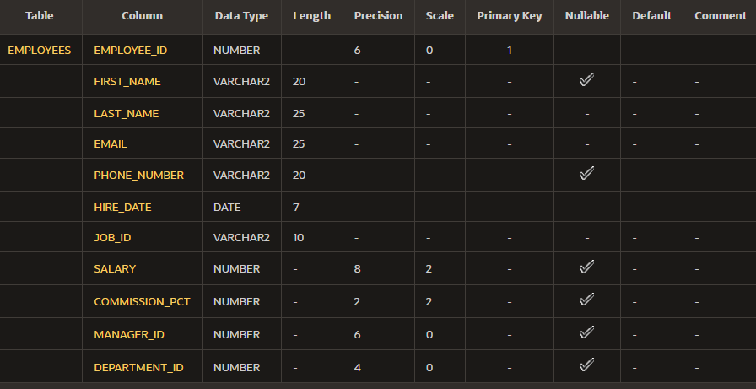

**Department Table**

CREATE TABLE Departments ( Dept_id NUMBER(6) NOT NULL, Dept_name VARCHAR(20) NOT NULL, Manager_id NUMBER(6), Location_id NUMBER(4), PRIMARY KEY (Dept_id), FOREIGN KEY (Manager_id) REFERENCES Employees(Employee_id) );

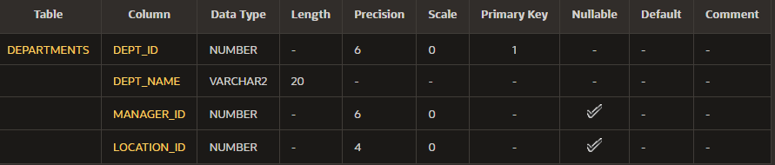

**Find the Solution for the following:**

1. The following statement executes successfully.

**Identify the Errors**

SELECT employee_id, last_name

sal*12 ANNUAL SALARY

FROM employees;

**Queries**

SELECT employee_id, last_name

sal*12 as “ANNUAL SALARY”

FROM employees;



1. Show the structure of departments the table. Select all the data from it.

Describe Departments;



Select * from departments;

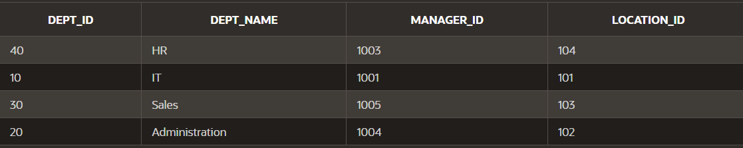

1. Create a query to display the last name, job code, hire date, and employee number for each employee, with employee number appearing first.

SELECT employee_id AS "Employee Number",

last_name AS "Last Name",

job_id AS "Job Code",

hire_date AS "Hire Date"

FROM employees;

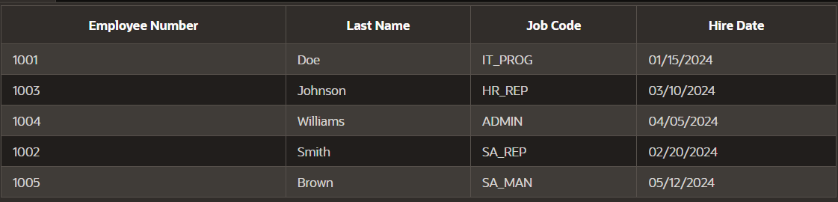

1. Provide an alias STARTDATE for the hire date.

SELECT employee_id,

last_name,

job_id,

hire_date AS "STARTDATE"

FROM employees;

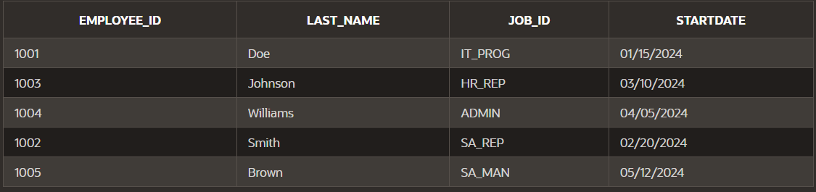

1. Create a query to display unique job codes from the employee table.

SELECT DISTINCT job_id

FROM employees;



1. Display the last name concatenated with the job ID , separated by a comma and space, and name the column EMPLOYEE and TITLE.

SELECT last_name || ', ' || job_id AS "EMPLOYEE, TITLE"

FROM employees;

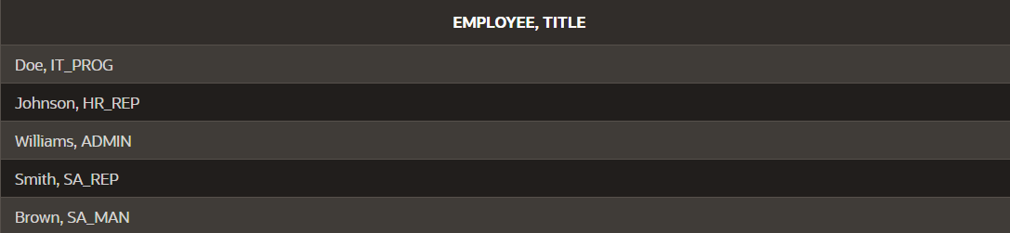

1. Create a query to display all the data from the employees table. Separate each column by a comma. Name the column THE_OUTPUT.

SELECT employee_id || ', ' || first_name || ', ' || last_name || ', ' || email || ', ' || phone_number || ', ' || hire_date || ', ' || job_id AS "THE_OUTPUT"

FROM employees;

